Churches’ Refugee Network

An informal network of

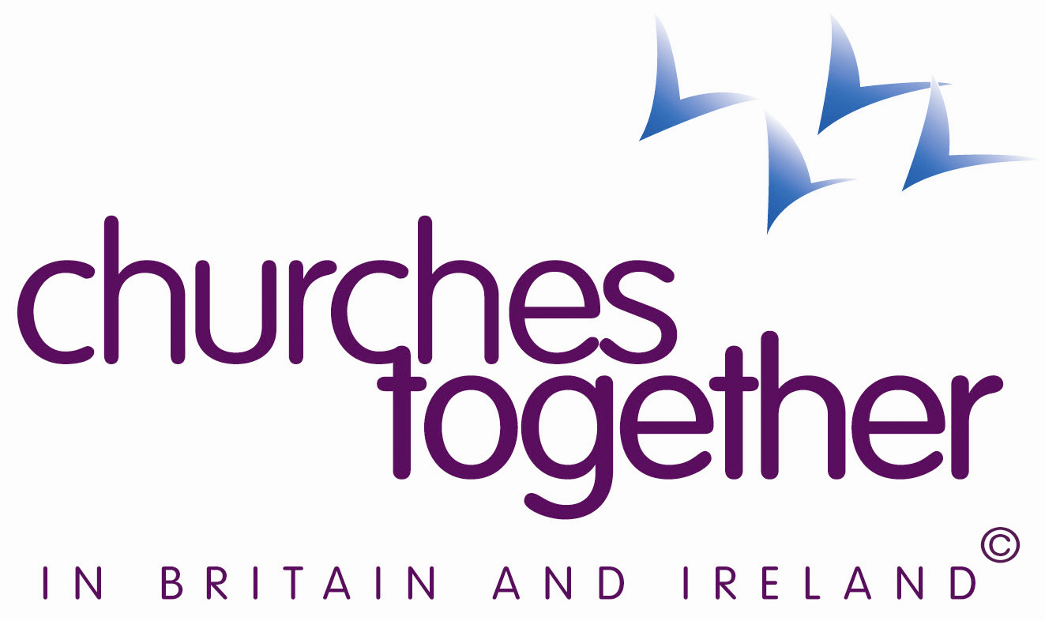
The Churches’ Refugee Network thanks the All Party Parliamentary Group on Refugees and the All Party Parliamentary Group on Migration for the thorough and substantial work they have done in their joint inquiry into the use of Immigration Detention in the United Kingdom, and for the report published this week. “The report is a searing indictment of the UK practice. As the report makes clear, in detaining people for indefinite periods of time, and for administrative purposes alone, the UK goes well beyond the practice in other European countries” said Jonathan Clark, Bishop of Croydon and chair of CRN.
Although the Government’s stated policy is that detention should be used sparingly and for the shortest possible time, the evidence received by the Commission in its six months inquiry is that the guidance is not adhered to, and that detainees are held indefinitely for long periods, with significant mental health costs to those detained and with huge and unnecessary costs to the public purse.
The Churches’ Refugee Network supports the Inquiry’s recommendations that indefinite detention should be abandoned and that, within a maximum time limit of 28 days, detention should be very rare and only for the shortest possible time in order to effect removal. The Inquiry examined a wide range of far less costly alternatives to detention used in other countries, and recommends that the Government should learn from international best practice.
It is not criminal to seek asylum. It is a basic, and long acknowledged, human right for those fleeing desperate conditions in their homeland. All people who seek sanctuary should be treated with dignity and respect. It is shocking that the Inquiry has found so many instances of this not being so in Britain. The Churches’ Refugee Network draws attention to the Inquiry’s finding that UK Detention Centres make use of conditions tantamount to high security prison settings, and its call for suitable accommodation conducive to an open and relaxed regime.
The Churches’ Refugee Network urges voters at the coming General Election to seek candidates’ commitments to bring about the changes called for by this cross-party Inquiry, especially the setting of 28-days as a maximum time limit to Detention.

